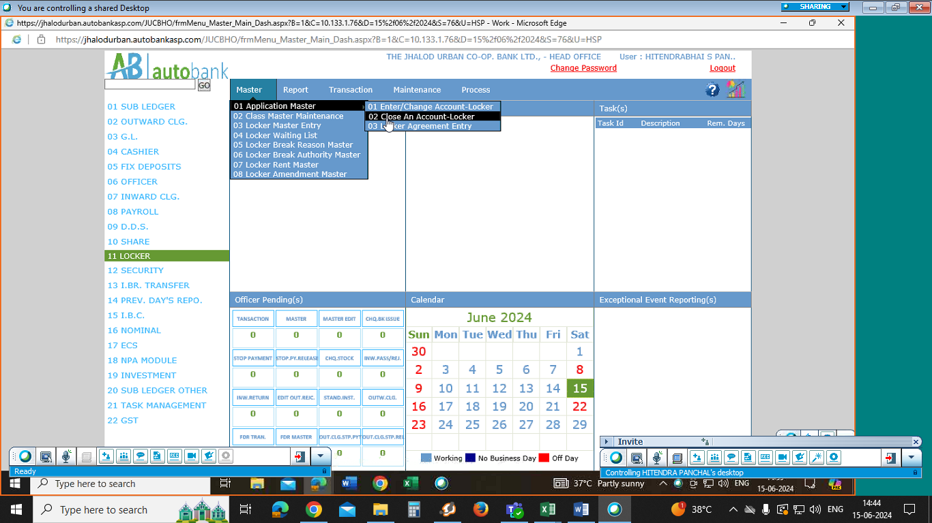path

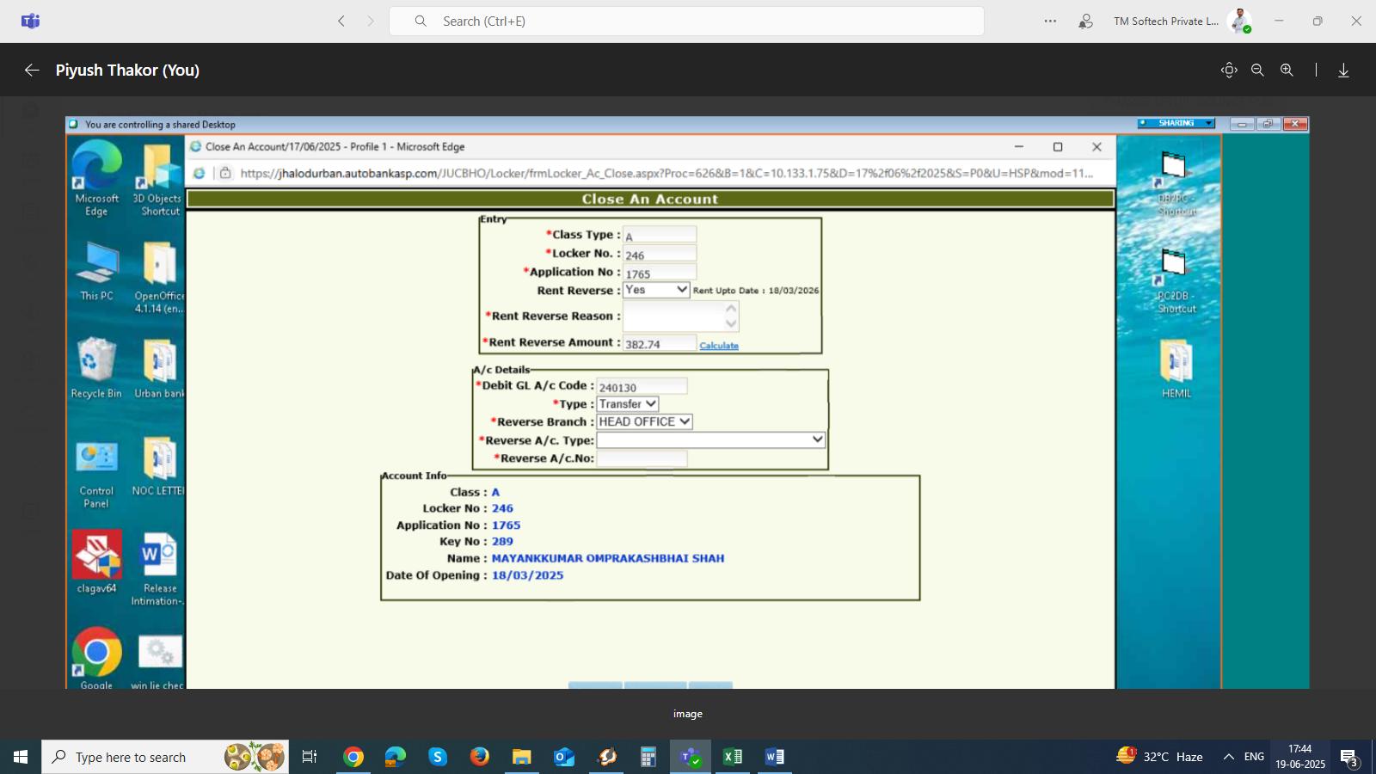

As on date 17-06-25 try to close this locker A-246 app 1765 .

Its showing rent reverse=382.74 for 274 days .

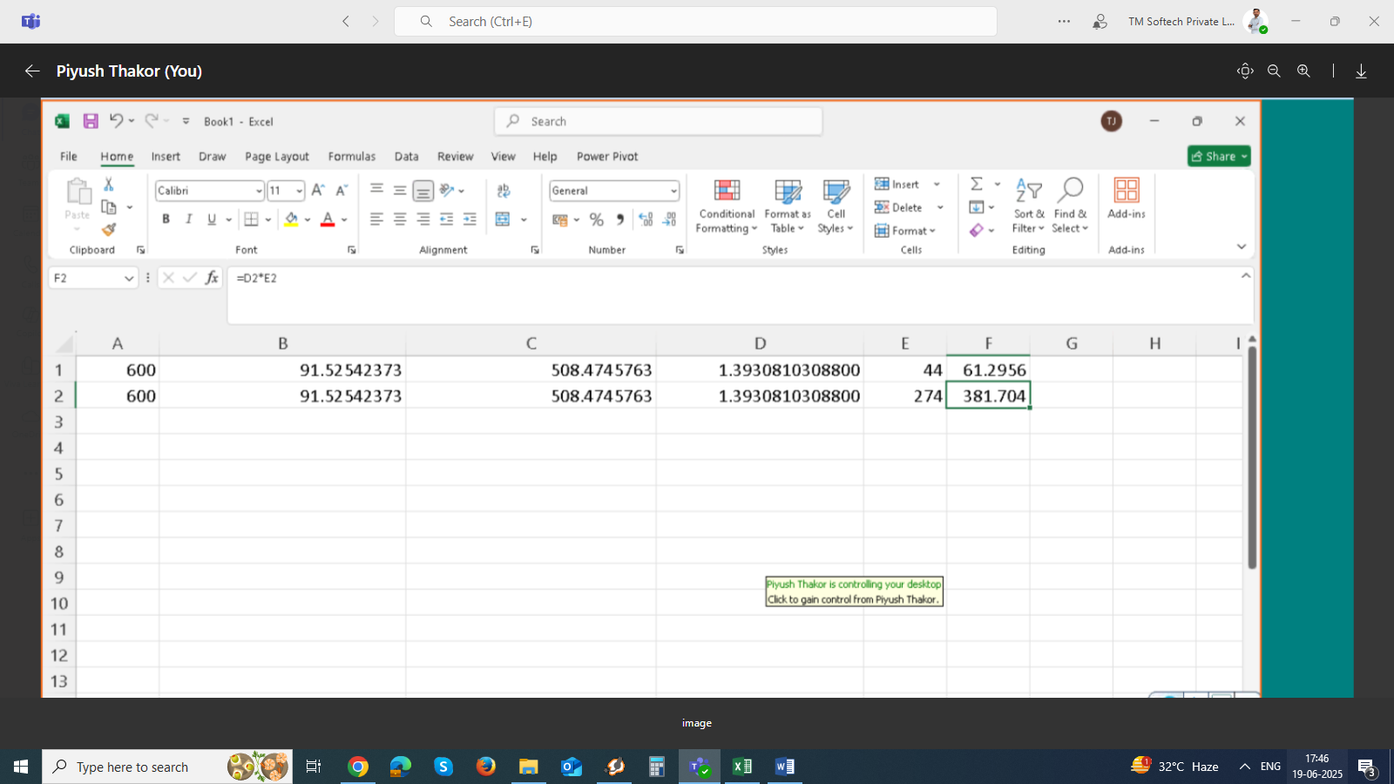as per his formula it should be 381.70 (More than 1 rs. Difference showing.)

Locker rent is including GST so actual rent 508.47 . or in some its count 508.46.

As per below example

